**Task No. 1:** Configure static route on the following network and show all necessary

configuration steps for each router.

**Solution**

**Router 0**

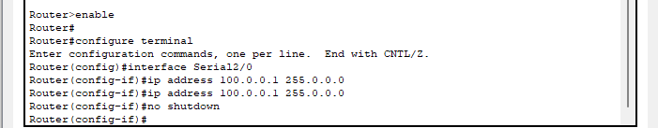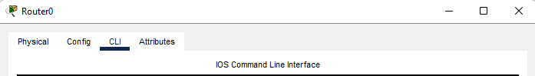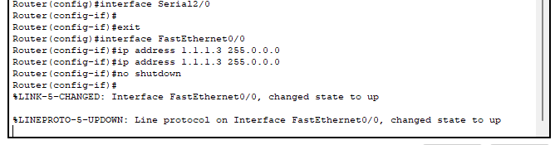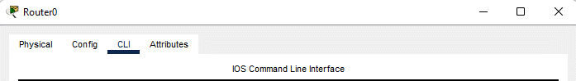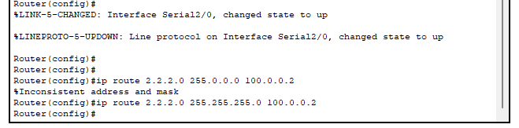

**Router 1**

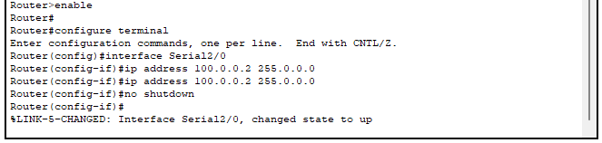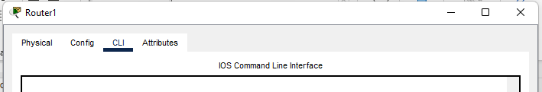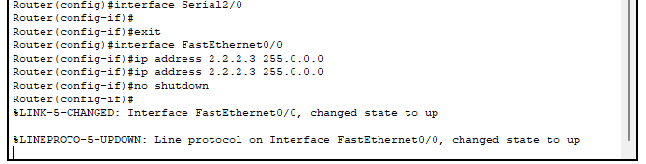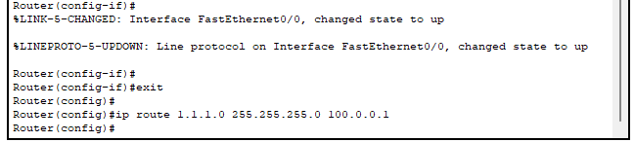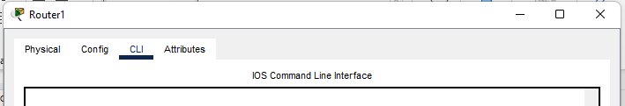

**PC1 To PC3 PC2 To PC4**

**PC3 To PC1 PC4 To PC2**

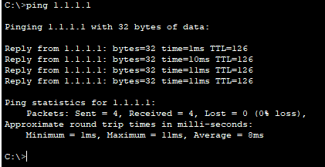

**PC1 To PC2 PC3 To PC4**

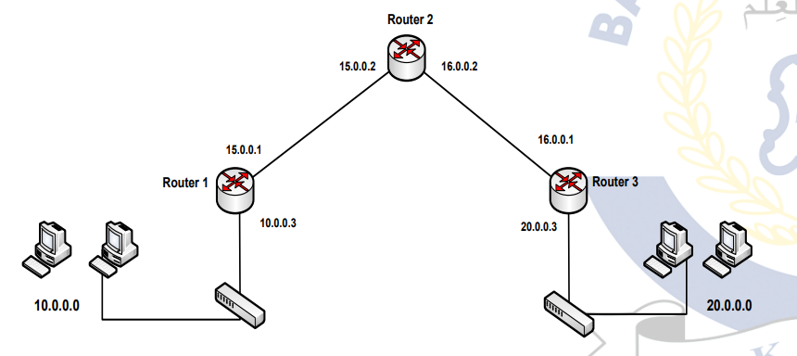**Task No. 2:** Configure static route on the following network and show all necessary

configuration steps for each router.

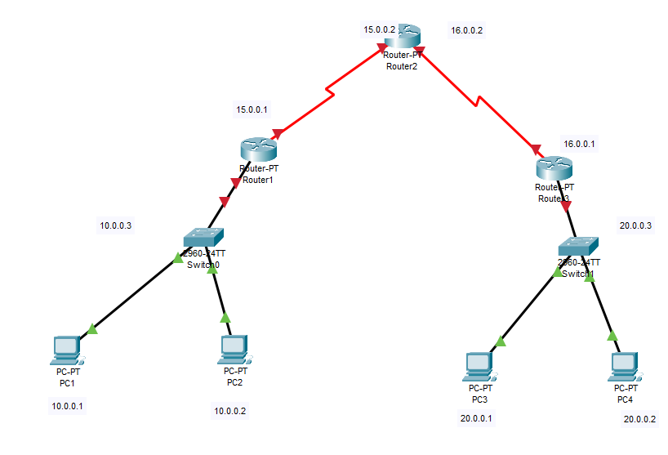

**Solution**

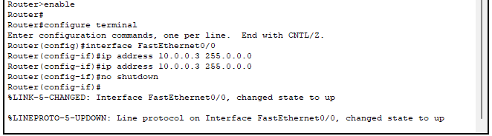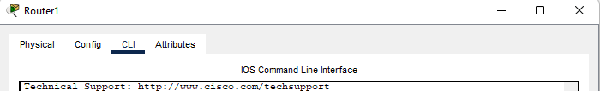

**Router 1**

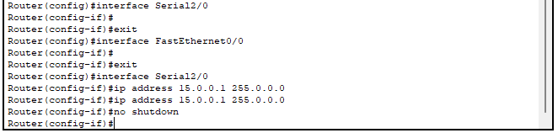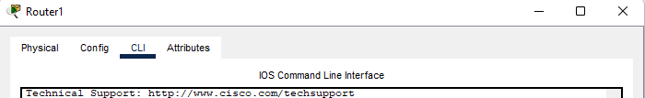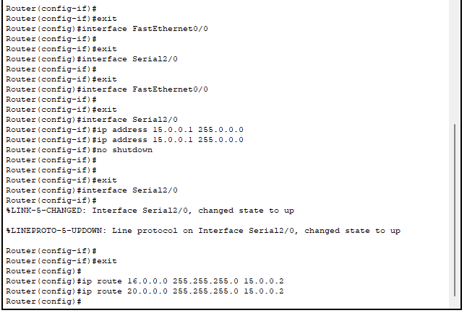

**Router 2**

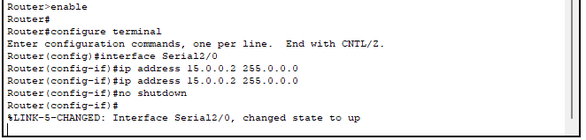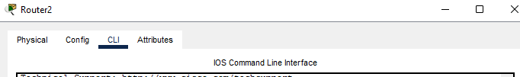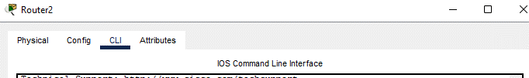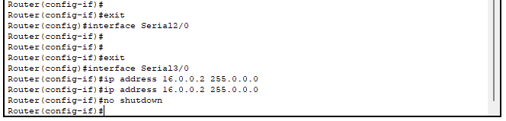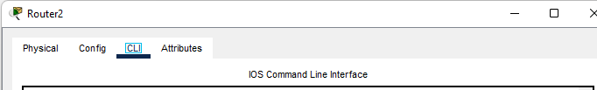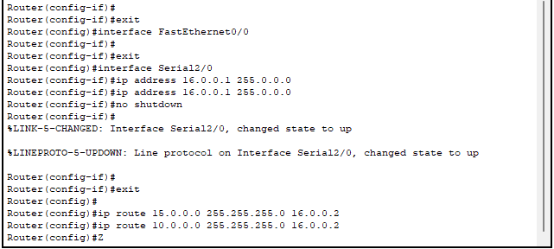

**Router 3**

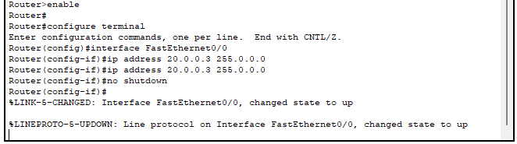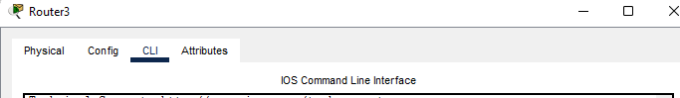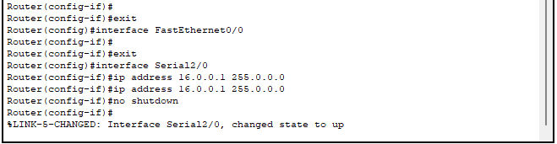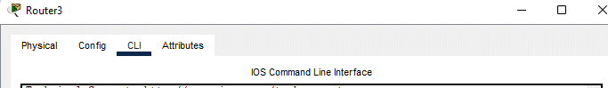

**PC1 To PC3 PC2 To PC4**

**PC3 To PC1 PC4 To PC2**

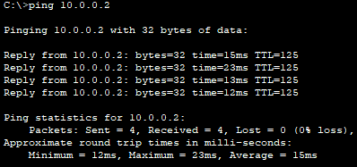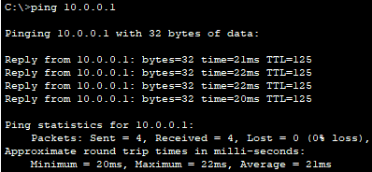

**PC1 To PC2 PC3 To PC4**

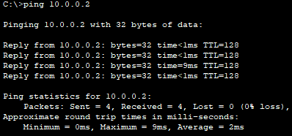

**PC1 To PC4 PC2 To PC3**

